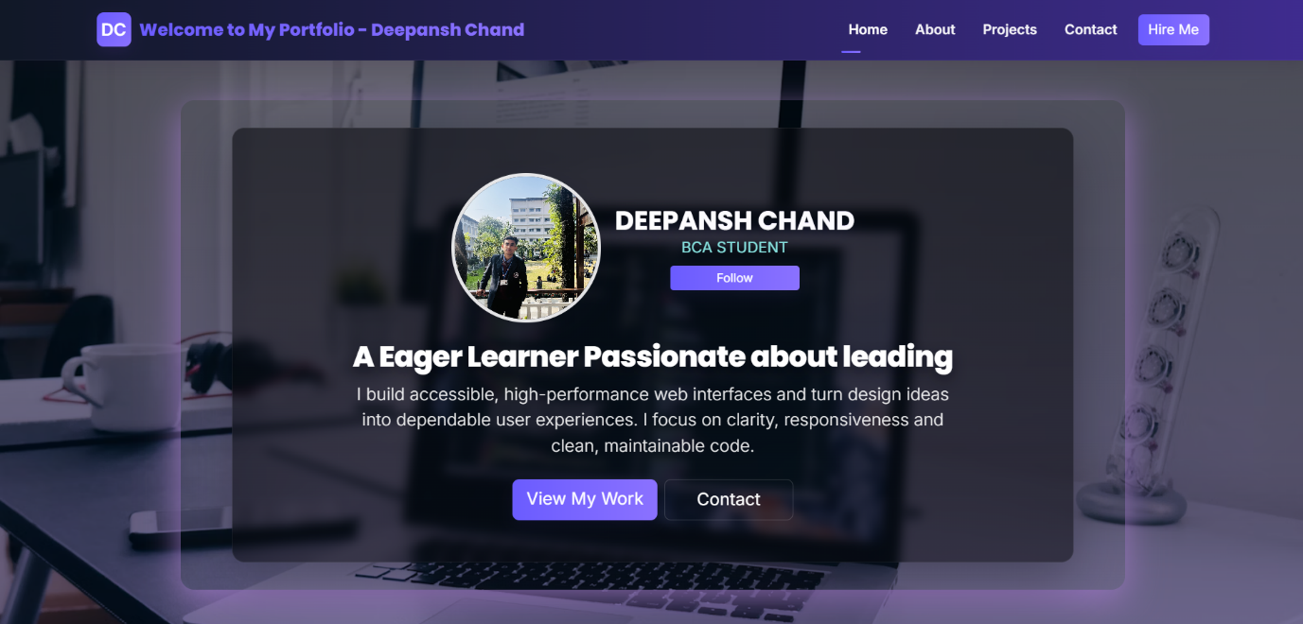

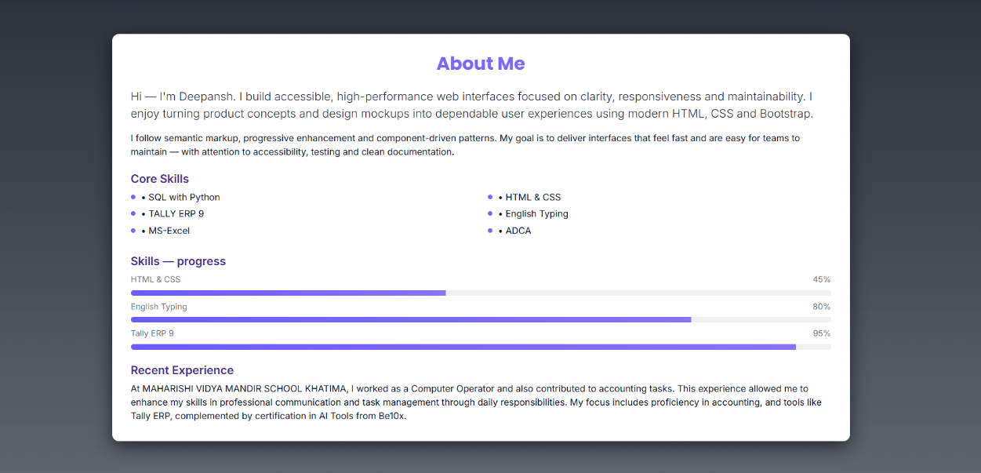

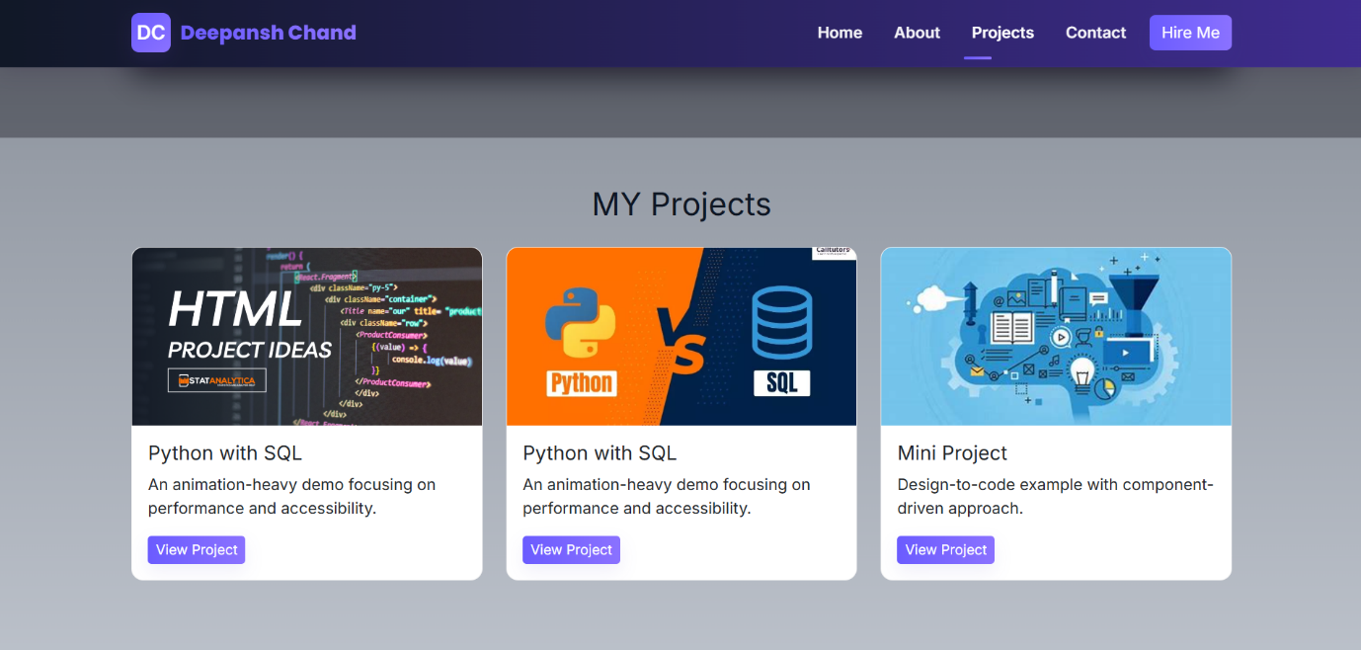

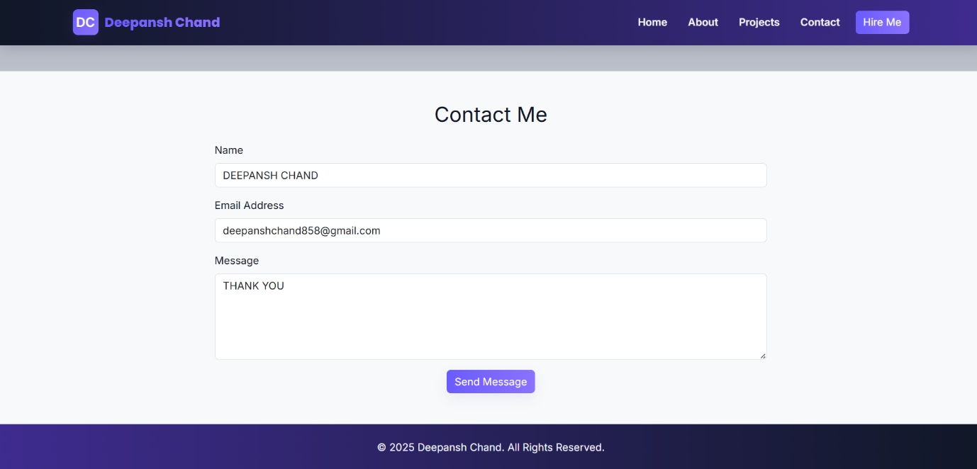

3 Columns
HTML CODE : -

<!DOCTYPE html>
<html lang="en">

<head>
<meta charset="UTF-8">
<meta name="viewport" content="width=device-width, initial-scale=1.0">
<title>Deepansh Chand - Portfolio</title>

<!-- Bootstrap -->
<link href="https://cdn.jsdelivr.net/npm/bootstrap@5.3.3/dist/css/bootstrap.min.css" rel="stylesheet"
integrity="sha384-QWTKZyjpPEjISv5WaRU9OFeRpok6YctnYmDr5pNlyT2bRjXh0JMhjY6hW+ALEwIH" crossorigin="anonymous">
<!-- Google Fonts -->
<link
href="https://fonts.googleapis.com/css2?family=Inter:wght@300;400;600&family=Poppins:wght@500;700;800&display=swap"
rel="stylesheet">
<!-- Font Awesome -->
<link rel="stylesheet" href="https://cdnjs.cloudflare.com/ajax/libs/font-awesome/6.4.0/css/all.min.css"
integrity="sha512-pb6XQ0f8YxE6qg4v1y+gWv2Z0cKQ6f9Jp1kP6x8Q8f5o9VZ6q1K5s1G1y0zY2a0Fz7F2yGv6mQ3s1b=="
crossorigin="anonymous" referrerpolicy="no-referrer" />
<link href="Extern4.css" rel="stylesheet">
</head>

<body data-bs-spy="scroll" data-bs-target="#mainNavbar" data-bs-offset="80">

<nav class="navbar navbar-expand-lg sticky-top" id="mainNavbar">
<div class="container">
<a class="navbar-brand" href="#home"><span class="brand-logo">DC</span><span class="brand-text">Welcome to
My Portfolio - Deepansh
Chand</span></a>
<button class="navbar-toggler" type="button" data-bs-toggle="collapse" data-bs-target="#nav"
aria-controls="nav" aria-expanded="false" aria-label="Toggle navigation">
<span class="navbar-toggler-icon"><i class="fas fa-bars"></i></span>
</button>
<div class="collapse navbar-collapse" id="nav">
<ul class="navbar-nav ms-auto align-items-lg-center">
<li class="nav-item"><a class="nav-link active" href="#home">Home</a></li>
<li class="nav-item"><a class="nav-link" href="#about">About</a></li>
<li class="nav-item"><a class="nav-link" href="#projects">Projects</a></li>
<li class="nav-item"><a class="nav-link" href="#contact">Contact</a></li>
</ul>
<div class="ms-3 d-none d-lg-inline-block">
<a href="#contact" class="btn btn-cta btn-primary custom">Hire Me</a>
</div>
</div>
</div>
</nav>

<header id="home" class="text-center">
<div class="container">
<div class="hero-card mx-auto" style="max-width:1100px">
<div class="hero-overlay">
<div class="profile-card">
<img src="Deepansh Chand.JPG" alt="Deepansh profile" class="profile-img">
<div class="profile-meta">
<h3>DEEPANSH CHAND</h3>
<p>BCA STUDENT</p>
<div class="mt-2 d-none d-sm-block"><a href="#contact"
class="btn btn-sm btn-primary custom">Follow</a></div>
</div>
</div>

<h1 style="font-size:2.1rem;">A Eager Learner Passionate about leading</h1>
<p class="lead">I build accessible, high-performance web interfaces and turn design ideas into
dependable user experiences. I focus on clarity, responsiveness and clean, maintainable code.
</p>
<div class="mt-4 d-flex justify-content-center gap-2">
<a href="#projects" class="btn btn-primary custom btn-lg">View My Work</a>
<a href="#contact" class="btn btn-outline-light btn-lg">Contact</a>
</div>
</div>
</div>
</div>
</header>

<section id="about" class="about-section">
<div class="container">
<div class="about-card">
<h2 class="text-center mb-4">About Me</h2>

<div class="row">
<div class="col-12">
<p class="lead mb-3 fade-up" style="transition-delay:.05s">Hi — I'm Deepansh. I build
accessible, high-performance web interfaces focused on clarity, responsiveness and
maintainability. I enjoy turning product concepts and design mockups into dependable user
experiences using modern HTML, CSS and Bootstrap.</p>
<p class="fade-up" style="transition-delay:.12s">I follow semantic markup, progressive
enhancement and component-driven patterns. My goal is to deliver interfaces that feel fast
and are easy for teams to maintain — with attention to accessibility, testing and clean
documentation.</p>
<h5 class="mt-4 fade-up" style="transition-delay:.36s">Core Skills</h5>
<div class="row mt-2 fade-up" style="transition-delay:.40s">
<div class="col-sm-6">
<ul class="list-unstyled mb-0">
<li>• SQL with Python</li>
<li>• TALLY ERP 9</li>
<li>• MS-Excel</li>
</ul>
</div>
<div class="col-sm-6">
<ul class="list-unstyled mb-0">
<li>• HTML & CSS</li>
<li>• English Typing</li>
<li>• ADCA</li>
</ul>
</div>
</div>

<h5 class="mt-4 fade-up" style="transition-delay:.46s">Skills — progress</h5>
<div class="skill-row fade-up" style="transition-delay:.48s">
<div class="skill-label"><span>HTML & CSS</span><span>45%</span></div>
<div class="skill-track">
<div class="skill-bar" data-target="45"></div>
</div>
<div class="skill-label"><span>English Typing</span><span>80%</span></div>
<div class="skill-track">
<div class="skill-bar" data-target="80"></div>
</div>
<div class="skill-label"><span>Tally ERP 9</span><span>95%</span></div>
<div class="skill-track">
<div class="skill-bar" data-target="95"></div>
</div>

</div>

<h5 class="mt-4 fade-up" style="transition-delay:.60s">Recent Experience</h5>
<p class="mb-0 fade-up" style="transition-delay:.64s">At MAHARISHI VIDYA MANDIR SCHOOL KHATIMA,
I worked as a Computer Operator and also contributed to accounting tasks. This experience
allowed me to enhance my skills in professional communication and task management through
daily responsibilities. My focus includes proficiency in accounting, and tools like Tally
ERP, complemented by certification in AI Tools from Be10x.</p>
</div>
</div>
</div>
</div>
</section>

<section id="projects" class="py-5">
<div class="container">
<h2 class="text-center mb-4">MY Projects</h2>
<div class="row">
<div class="col-md-4 mb-4">
<div class="card h-100">
<img src="htmcss.png" class="card-img-top" alt="Project 2 — developer workspace and monitor">
<div class="card-body">
<h5 class="card-title">Python with SQL</h5>
<p class="card-text">An animation-heavy demo focusing on performance and accessibility.</p>
<a href="#" class="btn btn-sm btn-primary custom text-white">View Project</a>
</div>
</div>
</div>
<div class="col-md-4 mb-4">
<div class="card h-100">
<img src="sqlpy.png" class="card-img-top" alt="Project 2 — developer workspace and monitor">
<div class="card-body">
<h5 class="card-title">Python with SQL</h5>
<p class="card-text">An animation-heavy demo focusing on performance and accessibility.</p>
<a href="#" class="btn btn-sm btn-primary custom text-white">View Project</a>
</div>
</div>
</div>
<div class="col-md-4 mb-4">
<div class="card h-100">
<img src="mini.jpeg" class="card-img-top" alt="Project 3 — desk setup and design sketches">
<div class="card-body">
<h5 class="card-title">Mini Project</h5>
<p class="card-text">Design-to-code example with component-driven approach.</p>
<a href="#" class="btn btn-sm btn-primary custom text-white">View Project</a>
</div>
</div>
</div>
</div>
</div>
</section>

<section id="contact" class="py-5 bg-light">
<div class="container">
<h2 class="text-center mb-4">Contact Me</h2>
<div class="row">
<div class="col-md-8 mx-auto">
<form novalidate>
<div class="mb-3">
<label for="name" class="form-label">Name</label>
<input type="text" class="form-control" id="name" required aria-required="true">
</div>
<div class="mb-3">
<label for="email" class="form-label">Email Address</label>
<input type="email" class="form-control" id="email" required aria-required="true">
</div>
<div class="mb-3">
<label for="message" class="form-label">Message</label>
<textarea class="form-control" id="message" rows="5" required
aria-required="true"></textarea>
</div>
<div class="text-center">
<button type="submit" class="btn btn-primary custom text-white">Send Message</button>
</div>
</form>
</div>
</div>
</div>
</section>

<footer class="py-4">
<div class="container text-center">
<p class="mb-0">&copy; 2025 Deepansh Chand. All Rights Reserved.</p>
</div>
</footer>

<!-- Bootstrap JS -->
<script src="https://cdn.jsdelivr.net/npm/bootstrap@5.3.3/dist/js/bootstrap.bundle.min.js"
integrity="sha384-YvpcrYf0tY3lHB60NNkmXc5s9fDVZLESaAA55NDzOxhy9GkcIdslK1eN7N6jIeHz"
crossorigin="anonymous"></script>

<script>
// Animations removed: typing and reveal-on-scroll scripts intentionally omitted.

// Simple form stub
(function () {
const form = document.querySelector('form');
if (!form) return;
form.addEventListener('submit', function (e) {
if (!form.checkValidity()) { e.preventDefault(); e.stopPropagation(); form.classList.add('was-validated'); }
else { e.preventDefault(); alert('Thanks — this demo page does not send messages. Integrate a backend to enable this.'); }
});
})();
// About section reveal & animate skill bars
(function () {
const io = new IntersectionObserver((entries) => {
entries.forEach(entry => {
if (entry.isIntersecting) {
const el = entry.target;
el.querySelectorAll('.fade-up').forEach(n => n.classList.add('in-view'));
el.querySelectorAll('.feature-pill').forEach(n => n.classList.add('in-view'));
// animate small skill bars inside left column
el.querySelectorAll('.skill-bar').forEach(bar => {
const target = bar.getAttribute('data-target') || bar.dataset.target || 0;
bar.style.width = parseInt(target, 10) + '%';
});
// also animate progress bars in the right card
el.querySelectorAll('.progress-bar[data-target]').forEach(pb => {
const t = pb.getAttribute('data-target');
pb.style.width = (t || 0) + '%';
});
io.unobserve(entry.target);
}
})
}, { threshold: 0.18 });

const about = document.querySelector('#about .about-card');
if (about) io.observe(about);
})();
</script>

</body>

</html>

CSS CODE : -
:root {
/* Medium-contrast theme: balanced slate with soft violet accents */
--g1: #6b5cff;
/* medium violet */
--g2: #8b72ff;
/* softer lilac */
--bg: linear-gradient(180deg, #0f1724 0%, #e9eef6 100%);
/* subtle two-tone for depth */
--text: #0f1724;
/* dark slate for readable text on lighter surfaces */
--muted: #6b7280;
/* muted slate */
--surface: #ffffff;
/* panels stay light for medium contrast */
--glass: rgba(245, 243, 255, 0.06);
--nav-dark-1: #111827;
/* dark slate for navbar */
--nav-dark-2: #3f2c8f;
/* violet tint */
--footer-dark: #0b1020;
--card-border: rgba(16, 24, 40, 0.06);
}

html {
scroll-behavior: smooth
}

body {
font-family: 'Inter', system-ui, -apple-system, Segoe UI, Roboto, "Helvetica Neue", Arial;
color: var(--text);
background: var(--bg);
-webkit-font-smoothing: antialiased;
-moz-osx-font-smoothing: grayscale;
}

/* Navbar (dark gradient) */
:root {
/* dark navbar variants that match main colors */
--nav1: var(--nav-dark-1);
--nav2: var(--nav-dark-2);
}

.navbar {
background: linear-gradient(90deg, var(--nav1) 0%, var(--nav2) 100%);
box-shadow: 0 6px 20px rgba(43, 12, 65, 0.14);
border-bottom: 1px solid rgba(255, 255, 255, 0.04);
padding-top: .6rem;
padding-bottom: .6rem;
}

/* Brand uses colorful gradient text for contrast */
.navbar-brand {
font-weight: 800;
display: flex;
align-items: center;
gap: .6rem
}

.brand-logo {
width: 40px;
height: 40px;
border-radius: 8px;
display: inline-flex;
align-items: center;
justify-content: center;
font-weight: 700;
color: white;
background: linear-gradient(135deg, var(--g1), var(--g2));
box-shadow: 0 6px 18px rgba(123, 63, 214, 0.12)
}

.navbar-brand .brand-text {
background: linear-gradient(90deg, var(--g1), var(--g2));
-webkit-background-clip: text;
background-clip: text;
color: transparent;
font-family: 'Poppins', system-ui, Arial
}

.nav-link {
color: rgba(255, 255, 255, 0.95) !important;
font-weight: 600;
margin-left: 1rem;
padding: .45rem .35rem
}

.nav-link:hover {
color: #ffffff !important
}

.nav-link.active {
color: #ffffff !important
}

/* active underline accent */
.nav-link.active {
position: relative
}

.nav-link.active::after {
content: '';
position: absolute;
left: 0;
bottom: -8px;
width: 36%;
height: 3px;
background: linear-gradient(90deg, var(--g1), var(--g2));
border-radius: 3px
}

/* Toggler icon (font-awesome) */
.navbar-toggler-icon i {
color: #ffffff;
font-size: 1.05rem
}

.navbar .btn-cta {
display: inline-flex;
align-items: center;
gap: .5rem
}

/* On mobile when collapsed, give collapse panel a dark gradient background for contrast */
@media(max-width:991px) {
.navbar-collapse {
background: linear-gradient(180deg, var(--nav2), var(--nav1));
padding: 1rem;
border-radius: 8px
}

.navbar-collapse .nav-link {
color: rgba(255, 255, 255, 0.98) !important
}

.navbar .btn-cta {
width: 100%;
justify-content: center;
margin-top: .6rem
}
}

/* Hero - updated: darker violet-tinted blend for stronger contrast with overlay */
header#home {
padding: 8rem 0;
/* darker tint blended over the photo to increase contrast for text */
background: linear-gradient(180deg, rgba(10, 12, 20, 0.65) 0%, rgba(58, 45, 112, 0.65) 100%), url('https://images.unsplash.com/photo-1498050108023-c5249f4df085?auto=format&fit=crop&w=1600&q=80');
background-size: cover;
background-position: center center;
background-blend-mode: multiply;
color: #ffffff;
position: relative;
overflow: hidden;
}

/* watermark: single centered technical logo (medium contrast) */
header#home::after {
content: '';
position: absolute;
inset: 0;
/* single SVG logo centered (</> mark) to give a technical badge feel */
background-image: url("data:image/svg+xml;utf8,<svg xmlns='http://www.w3.org/2000/svg' width='420' height='420'><rect width='100%' height='100%' fill='none'/><text x='50%' y='50%' font-size='96' text-anchor='middle' fill='%236b5cff' fill-opacity='0.08' font-family='Poppins,Arial,Helvetica,sans-serif'>&lt;/&gt;</text></svg>");
background-repeat: no-repeat;
background-position: center center;
background-size: 360px 360px;
opacity: 0.08;
pointer-events: none;
z-index: 1;
filter: grayscale(10%) contrast(1) brightness(1);
}

/* Centered translucent overlay card (updated for darkened hero background) */
.hero-overlay {
max-width: 980px;
margin: 0 auto;
text-align: center;
padding: 3rem 2rem;
/* make the overlay slightly dark/translucent so white text reads well */
background: linear-gradient(180deg, rgba(6, 7, 12, 0.58), rgba(6, 7, 12, 0.54));
border-radius: 14px;
border: 1px solid rgba(255, 255, 255, 0.06);
backdrop-filter: blur(6px);
box-shadow: 0 20px 60px rgba(6, 8, 16, 0.36);
position: relative;
z-index: 2;
color: #ffffff;
}

.hero-overlay h1 {
font-family: 'Poppins', system-ui, Arial;
font-size: 2.8rem;
margin-bottom: .5rem;
font-weight: 800;
letter-spacing: -0.6px;
/* use high-contrast white on the darker overlay for readability */
color: #ffffff;
text-shadow: 0 6px 18px rgba(6, 8, 16, 0.6);
}

.hero-overlay p.lead {
color: rgba(255, 255, 255, 0.92);
max-width: 56ch;
margin: 0 auto;
}

.hero-overlay .btn {
min-width: 150px;
color: #ffffff;
}

/* ensure outline-light buttons are visible on dark overlay */
.btn-outline-light {
color: #ffffff !important;
border-color: rgba(255, 255, 255, 0.18);
}

/* small profile accent top-right */
/* hero profile placed mid-page (center of overlay) */
.hero-profile-mid {
width: 140px;
height: 140px;
border-radius: 50%;
object-fit: cover;
border: 5px solid rgba(255, 255, 255, 0.92);
box-shadow: 0 12px 34px rgba(16, 24, 40, 0.18);
display: block;
margin: 0 auto 1rem
}

/* Profile card inside hero (image + meta + CTA) */
.profile-card {
display: flex;
align-items: center;
gap: 1rem;
justify-content: center;
max-width: 720px;
margin: 0 auto 1rem;
padding: 0.25rem 0.5rem;
}

.profile-card .profile-img {
width: 175px;
height: 175px;
border-radius: 50%;
object-fit: cover;
border: 4px solid rgba(255, 255, 255, 0.886);
box-shadow: 0 12px 34px rgba(16, 24, 40, 0.14);
}

.profile-meta h3 {
margin: 0;
font-family: 'Poppins', system-ui, Arial;
font-size: 1.9rem;
font-weight: 600;
/* light/gradient effect for the profile name */
background: linear-gradient(90deg, rgba(255, 255, 255, 0.98), rgba(235, 226, 255, 0.96));
-webkit-background-clip: text;
background-clip: text;
-webkit-text-fill-color: transparent;
color: transparent;
/* subtle glow to lift text from the panel */
text-shadow: 0 1px 0 rgba(255, 255, 255, 0.85), 0 8px 20px rgba(107, 92, 246, 0.08);
}

.profile-meta p {
margin: 0;
color: rgb(136, 228, 225);
font-size: 1.1rem;
}

@media(max-width:767px) {
.profile-card {
flex-direction: column;
text-align: center
}

.profile-card .profile-img {
width: 150px;
height: 150px
}

.profile-meta h3 {
font-size: 1.1rem
}
}

/* hide previous small accent to avoid duplicate visuals */
.hero-accent {
display: none
}

@media(max-width:991px) {
header#home {
padding: 5rem 0
}

.hero-overlay h1 {
font-size: 1.8rem
}

.hero-accent {
display: none
}
}

.hero-card {
background: linear-gradient(180deg, rgba(255, 255, 255, 0), rgba(255, 255, 255, 0.02));
border-radius: 16px;
padding: 2rem;
box-shadow: 0 12px 40px rgb(152, 117, 192)
}

/* New split hero layout (left text, right profile/cards) */
.hero-split {
display: grid;
grid-template-columns: 1fr 1fr;
gap: 2rem;
align-items: center;
}

.hero-left {
text-align: left
}

.hero-left .kicker {
text-transform: uppercase;
font-size: .8rem;
color: var(--muted);
font-weight: 700;
letter-spacing: .12em
}

.hero-left h1 {
font-family: 'Poppins', system-ui, Arial;
font-size: 2.6rem;
margin: .25rem 0;
background: linear-gradient(90deg, var(--g1), var(--g2));
-webkit-background-clip: text;
background-clip: text;
color: transparent
}

.hero-left p.lead {
color: rgba(11, 18, 36, 0.85);
max-width: 36rem
}

.hero-features {
display: flex;
gap: 1rem;
margin-top: 1rem;
flex-wrap: wrap
}

.feature-pill {
background: linear-gradient(90deg, var(--g1), var(--g2));
color: #fff;
padding: .45rem .7rem;
border-radius: 999px;
font-weight: 700
}

.hero-right {
text-align: center
}

.profile-large {
width: 180px;
height: 180px;
border-radius: 50%;
object-fit: cover;
border: 6px solid rgba(255, 255, 255, 0.95);
box-shadow: 0 18px 48px rgba(16, 24, 40, 0.12);
display: inline-block
}

.project-preview {
display: flex;
gap: .75rem;
margin-top: 1rem;
justify-content: center
}

.preview-card {
width: 140px;
border-radius: 12px;
overflow: hidden;
box-shadow: 0 10px 30px rgba(16, 24, 40, 0.06);
border: 1px solid rgba(16, 24, 40, 0.04);
background: var(--surface)
}

.preview-card img {
width: 100%;
height: 84px;
object-fit: cover
}

@media(max-width:991px) {
.hero-split {
grid-template-columns: 1fr;
text-align: center
}

.hero-left {
order: 2
}

.hero-right {
order: 1
}

.hero-left h1 {
font-size: 1.8rem
}
}

.hero-title {
font-weight: 800;
letter-spacing: -1px
}

.hero-sub {
opacity: 0.92
}

/* Hero badges and refined hero title (professional) */
.hero-title {
font-weight: 800;
letter-spacing: -1px;
font-family: 'Poppins', system-ui, Arial;
background: linear-gradient(90deg, var(--g1), var(--g2));
-webkit-background-clip: text;
background-clip: text;
color: transparent;
}

.hero-badges {
display: flex;
gap: .5rem;
justify-content: center;
margin-top: 1rem;
flex-wrap: wrap
}

.hero-badges .badge {
background: linear-gradient(90deg, var(--g1), var(--g2));
color: #fff;
padding: .35rem .65rem;
border-radius: 999px;
font-weight: 700;
box-shadow: 0 10px 30px rgba(139, 92, 246, 0.10)
}

/* small highlight inside subtitle */
.hero-sub .highlight {
background: linear-gradient(90deg, var(--g1), var(--g2));
-webkit-background-clip: text;
background-clip: text;
color: transparent;
font-weight: 700
}

/* Right-side stat / project card */
.stat-card {
max-width: 320px;
margin: 0 auto;
background: linear-gradient(180deg, rgba(255, 255, 255, 0.98), rgba(250, 246, 255, 0.95));
border-radius: 16px;
padding: 1rem;
border: 1px solid rgba(139, 92, 246, 0.08);
box-shadow: 0 12px 36px rgba(139, 92, 246, 0.06)
}

.stat-items {
display: flex;
gap: .6rem;
justify-content: space-between
}

.stat-item {
flex: 1;
text-align: center;
padding: .6rem
}

.stat-item .num {
font-family: 'Poppins', system-ui, Arial;
font-size: 1.35rem;
font-weight: 800;
background: linear-gradient(90deg, var(--g1), var(--g2));
-webkit-background-clip: text;
background-clip: text;
color: transparent
}

.stat-item .label {
font-size: .85rem;
color: var(--muted)
}

.stat-image {
width: 100%;
height: 90px;
object-fit: cover;
border-radius: 10px;
margin-top: .8rem;
box-shadow: 0 8px 22px rgba(16, 24, 40, 0.06)
}

/* Profile circle */
.profile-img {
width: 160px;
height: 160px;
border-radius: 50%;
object-fit: cover;
border: 6px solid rgba(255, 255, 255, 0.9);
position: relative;
display: block;
z-index: 2;
box-shadow: 0 8px 26px rgba(16, 24, 40, 0.08);
}

/* Profile halo / shine */
.profile-wrap {
position: relative;
display: inline-block;
border-radius: 50%;
padding: 6px
}

.profile-wrap::before {
/* subtle static halo in purple tones */
content: "";
position: absolute;
left: 50%;
top: 50%;
transform: translate(-50%, -50%);
width: 260px;
height: 260px;
border-radius: 50%;
background: radial-gradient(circle at 30% 30%, rgba(200, 170, 255, 0.52), rgba(167, 139, 250, 0.32) 40%, rgba(167, 139, 250, 0.06) 60%, transparent 72%);
filter: blur(18px);
z-index: 0;
pointer-events: none;
}

.profile-wrap::after {
/* subtle glossy overlay */
content: "";
position: absolute;
inset: 0;
border-radius: 50%;
background: linear-gradient(120deg, rgba(255, 255, 255, 0.14), rgba(255, 255, 255, 0.02));
mix-blend-mode: screen;
z-index: 2;
pointer-events: none;
}

/* pulse animation removed for a static professional halo */

/* Typing (static) */
.typing {
padding-right: 8px;
white-space: nowrap;
display: inline-block
}

/* Sections */
section {
padding: 4.5rem 0
}

/* About section — dark variant */
#about.about-section {
background: linear-gradient(180deg, rgba(8, 7, 14, 0.48), rgba(10, 9, 18, 0.36));
}

.about-card {
background: var(--surface);
border-radius: 12px;
padding: 2rem;
box-shadow: 0 10px 30px rgba(2, 4, 12, 0.6);
border: 1px solid var(--card-border);
}

/* About text color and accents */
.about-card h2 {
font-family: 'Poppins', system-ui, Arial;
font-weight: 700;
background: linear-gradient(90deg, var(--g1), var(--g2));
-webkit-background-clip: text;
background-clip: text;
color: transparent;
}

.about-card h5 {
color: var(--nav2);
font-weight: 700
}

.about-card p.lead {
color: rgba(15, 18, 36, 0.9)
}

/* Animated reveal helpers for About */
.fade-up {
opacity: 0;
transform: translateY(12px);
transition: opacity .6s ease, transform .6s ease;
}

.fade-up.in-view {
opacity: 1;
transform: translateY(0);
}

.feature-pill {
background: linear-gradient(90deg, var(--g1), var(--g2));
color: #fff;
padding: .35rem .7rem;
border-radius: 999px;
font-weight: 700;
display: inline-block;
transform: scale(.96);
transition: transform .45s cubic-bezier(.2, .9, .2, 1), opacity .45s ease;
opacity: 0;
}

.feature-pill.in-view {
transform: scale(1);
opacity: 1;
}

.skill-row {
display: grid;
gap: .5rem;
margin-top: .6rem;
}

.skill-label {
display: flex;
justify-content: space-between;
font-size: .9rem;
color: var(--muted);
}

.skill-track {
background: rgba(15, 18, 36, 0.06);
height: 10px;
border-radius: 999px;
overflow: hidden;
}

.skill-bar {
width: 0%;
height: 100%;
background: linear-gradient(90deg, var(--g1), var(--g2));
transition: width 1.1s cubic-bezier(.2, .9, .2, 1);
}

/* Colored bullet accents for lists inside about */
.about-card .list-unstyled li {
position: relative;
padding-left: 18px;
margin-bottom: .35rem
}

.about-card .list-unstyled li::before {
content: '';
width: 8px;
height: 8px;
border-radius: 50%;
background: linear-gradient(90deg, var(--g1), var(--g2));
position: absolute;
left: 0;
top: 8px
}

/* Cards (static, no motion) */
.card {
background: var(--surface);
border: 1px solid var(--card-border);
border-radius: 12px;
overflow: hidden;
transition: box-shadow .18s ease;
}

.card:hover {
box-shadow: 0 18px 48px rgba(107, 92, 246, 0.08);
}

.card-img-top {
height: 180px;
object-fit: cover
}

/* CSS-based illustration for a project card (gradient + subtle code-line motif) */
.card-img-css {
height: 180px;
display: block;
background-image: linear-gradient(135deg, rgba(255, 255, 255, 0.06), rgba(0, 0, 0, 0.04)), linear-gradient(90deg, var(--g1), var(--g2));
background-blend-mode: overlay;
background-size: cover;
position: relative;
}

/* faint repeating lines to mimic code lines */
.card-img-css::before {
content: "";
position: absolute;
inset: 0;
background-image: repeating-linear-gradient(to bottom, rgba(255, 255, 255, 0.06) 0 2px, transparent 2px 12px);
pointer-events: none;
mix-blend-mode: overlay;
}

/* subtle centered code-brackets mark */
.card-img-css::after {
content: "</>";
position: absolute;
left: 50%;
top: 50%;
transform: translate(-50%, -50%);
font-family: 'Poppins', Arial, Helvetica, sans-serif;
font-weight: 700;
color: rgba(255, 255, 255, 0.9);
font-size: 36px;
opacity: 0.88;
letter-spacing: 1px;
pointer-events: none;
text-shadow: 0 6px 18px rgba(16, 24, 40, 0.18);
}

/* Reveal removed - elements are static */
.reveal {
opacity: 1;
transform: none
}

/* Buttons */
.btn-primary.custom {
background: linear-gradient(90deg, var(--g1), var(--g2));
border: 0;
box-shadow: 0 8px 18px rgba(79, 60, 197, 0.08);
}

/* Contact */
.form-control:focus {
box-shadow: 0 0 0 .18rem rgba(107, 92, 246, 0.12);
border-color: rgba(107, 92, 246, 0.8)
}

footer {
background: linear-gradient(90deg, var(--nav2), var(--nav1));
color: #f0f2ff;
}

@media(min-width:992px) {
.hero-layout {
display: flex;
align-items: center;
gap: 2rem
}

.hero-left {
flex: 1
}

.hero-right {
flex: 1
}
}

